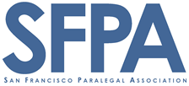  PARALEGAL  DAY 2015  Saturday, May 2  8:30 am – 4:30 pm at  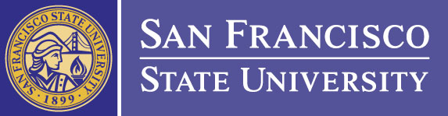  San Francisco State University Downtown Campus  835 Market Street 6th Floor San Francisco  above Powell Street Bart  Registration starts at 8:30 with coffee and continental breakfast; Lunch 1:00 – 2:00 Presentations start at 9:15 REGISTRATION (through May 1] $20 Students $60 SFPA Members $85 non-members AT THE DOOR May 2 $25 Students $70 SFPA Members $95 non-members  REGISTER AT WWW.SFPA.COM under Upcoming Events  Non-refundable after 72 hours from registration; Student charge reflects cost of breakfast and lunch; Student ID must be presented at registration; Times and speakers subject to change |  |  | kEYNOTE aDDRESS  by KERRY SPENCE  People’s Legal Docs  SPECIAL TWO-TRACK  PRESENTATION by  SACHIT KAMAT  PROFILE PRODUCTS LEADER at LINKEDIN  Professi0nal track  PRESENTERS  VINCE AVElLINO  BPC 6400 AND 6450  STEVE BURGESS  COMPUTER FORENSICS  JIM WILLIAMS  EDISCOVERY & SOCIAL MEDIA  STUDENT track  PRESENTERS  SFPA & FRIENDS  paras at work  SHELLE MARTIN Merrilcorp  KATHLEEN SHEPPARD & NAISSA FOSTER HANSON BRIDGETT LLP  ELIZABETH OLVERA, SF District attorney’s office  NO FEAR INTERVIEW  Amy Goltz EASTRIDGE RESEARCH  IAN STEMER ONE POINT LEGAL  PHOENIX O’BRIEN FILLMORE SEARCH  PARALEGALS – BEST USE & EXPECTATIONS  SIGRID IRIAS, ESQ. IRIAS LAW  CHUCK GEERHART, ESQ PAOLI &GEERHART

